N° | Area | Context | Artifact type | Artifact sub-type | Colour | Number | Comment | Photo
1 | 5 | NA | Glass | Raw glass fragment | Natural bluish and red | 1 |  | 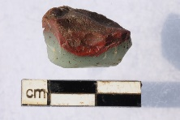
2 | 5 | NA | Glass | Waste production | Green | 1 | Thread of glass | 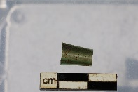
3 | 5 | NA | Glass | Raw glass fragment | Brown | 1 |  | 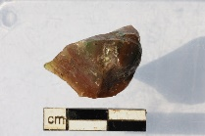
4 | 3 | NA | Glass | Waste production and beads | all | 32 |  | 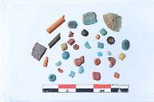
5 | 3 | NA | Glass | Fragment | all | 17 |  | 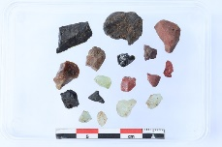
6 | 3 | NA | Glass | Fragment | Blue | 51 |  | 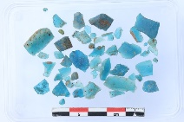
7 | 5 | NA | Glass | Slab surface | Natural Green, Red, Black | 1 |  | 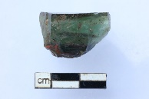
8 | 5 | NA | Glass | Furnace bottom | Red | 1 |  | 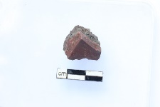
9 | 5 | NA | Glass | Waste production | Blue | 2 |  | 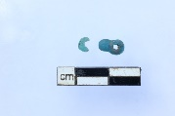
10 | 5 | NA | Glass | Waste production | Black | 3 |  | 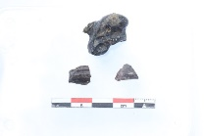
11 | 5 | NA | Glass | Raw glass fgt | Blue | 4 |  | 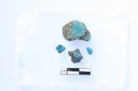
12 | F1 | C4 | Glass | Waste production | Red | 1 | Thread of glass | 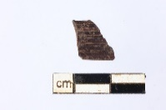
13 | F1 | C4 | Glass | Fragment | Black | 5 |  | 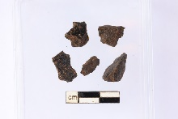
14 | F1 | C5 | Building material | Glass layered furnace fragment | Red and black | 4 |  | 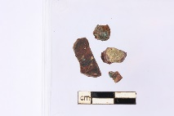
15 | F1 | C10 | Glass | Waste production | Red | 1 | Thread of glass | 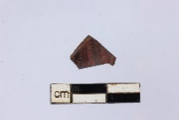
16 | F1 | C13 | Building material | Glass layered furnace fragment | Natural Green, Red, Black | 1 |  | 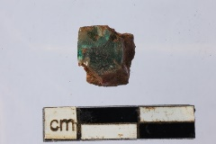
17 | F1 | C14 | Building material | Glass layered furnace fragment | Black | 1 |  | 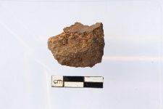
18 | F1 | C14 | Glass | Waste production | Natural and Black | 3 | Thread of glass | 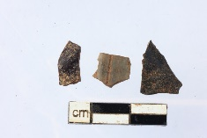
19 | F1 | C16 | Glass | Waste production | Natural green | 2 |  | 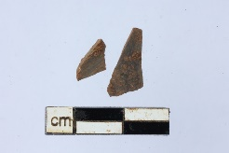
20 | F1 | C16 | Glass | Fragment | Red Brown | 4 |  | 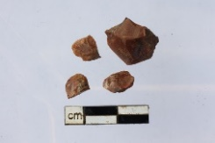
21 | F3 | C2 | Glass | Waste production | Green | 1 | Drop | 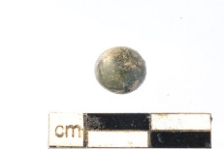
22 | F3 | C7 | Glass | Fragment | Natural green | 5 |  | 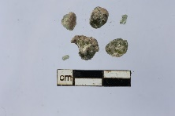
23 | 5 | NA | Pottery | Crucible | White and natural green | 2 |  | 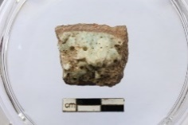
24 | 5 | NA | Building material | Glass layered furnace fragment | Green | 1 |  | 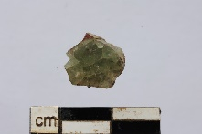
25 | 5 | NA | Building material | Glass layered furnace fragment | Black | 2 | 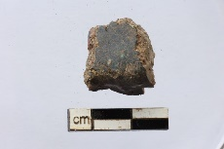 | 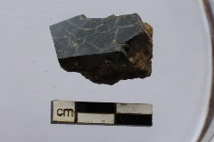
26 | F1 | C18 | Glass | Waste production | Red and orange | 2 | 2 red beads, 1 orange tube | 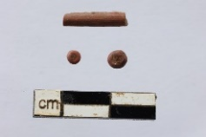
27 | F1 | C18 | Building material | Glass layered furnace fragment | Black | 1 |  | 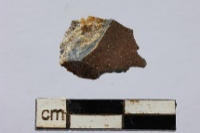
28 | F1 | C18 | Building material | Furnace fragment with glass | Red | 1 |  | 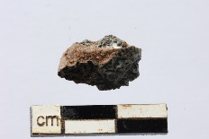
29 | F1 | Surface | Glass | Waste production | Translucent brown | 1 | drop | 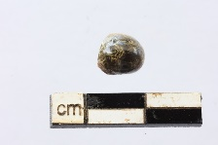
30 | F3 | C1 | Building material | Glass layered furnace fragment | Natural Green, Red, Black | 2 | 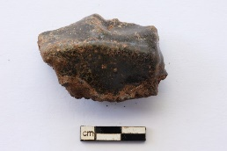 | 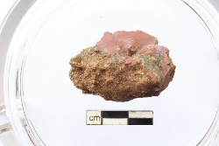
31 | F3 | C1 | Glass | Raw glass fragment | Red and black | 6 |  | 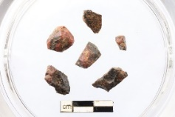
32 | F3 | C16 | Glass | Waste production | Red | 2 | one bead and one tube | 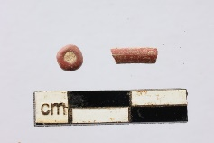
33 | F3 | C16 | Glass | Fragment | Natural green, red, black, blue | 49 |  | 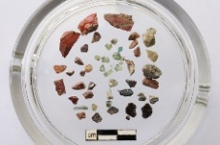
34 | 1 | NA | Glass | Waste production | all | 40 | and two crucible | 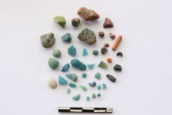
35 | 5 | NA | Building material | Glass layered furnace fragment | Black and green | 11 | one green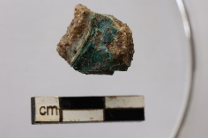 | 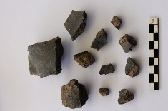
36 | F1 | C23 | Glass | Waste production | Red brown black | 5 |  | 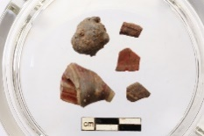
37 | F1 | C23 | Building material | Glass layered furnace fragment | Green, black and red | 2 | 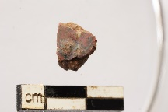 | 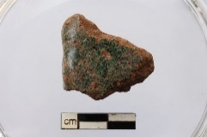
38 | 1 | NA | Glass | Waste production and beads | all | 15 |  | 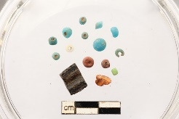
39 | 4 | NA | Pottery | Crucible | Black, blue, white | 22 | 3 rims | 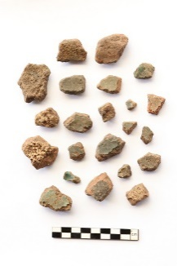
40 | 2 | point 9 | Glass | Waste production | Green and red | 4 | 1 tube and 3 beads | 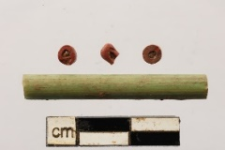
41 | 8 | NA | Building material | Glass layered furnace fragment | Green and red | 2 | 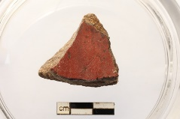 | 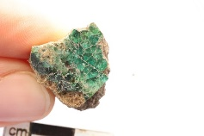
42 | F4 | C1 | Building material | Glass layered furnace fragment | Green, black and red | 3 | 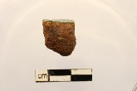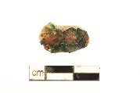 | 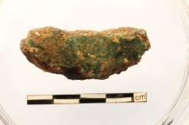
43 | 5 | NA | Building material | Raw glass on furnace fragment | Brown | 1 |  | 